JavaScript Task (30SS JUL 2025)
Name: Manas Pinjarkar
Prn: 23070521089
Sem/Sec: 5th (B)
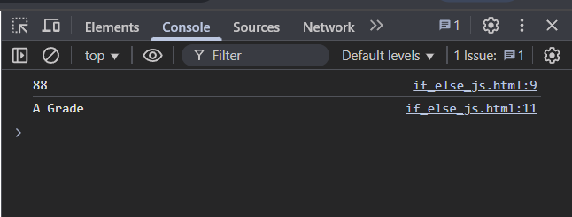
Task 1
Result:


Task 2
Result:


